**MODULE: 10 List and Hooks**

* **Explain Life cycle in Class Component and functional component with Hooks**

**Ans.:**

**Phases of a React component's lifecycle**

A React component undergoes three phases in its lifecycle: mounting, updating, and unmounting.

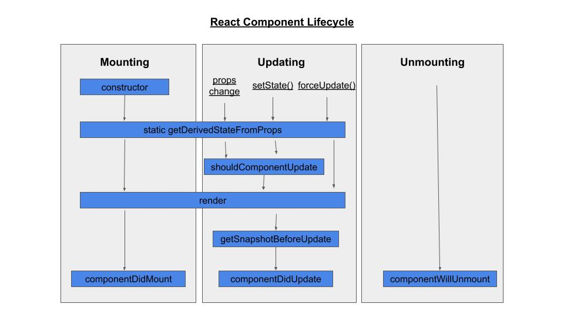

1. The *mounting phase* is when a new component is created and inserted into the DOM or, in other words, when the life of a component begins. This can only happen once, and is often called “initial render.”
2. The *updating phase* is when the component updates or re-renders. This reaction is triggered when the props are updated or when the state is updated. This phase can occur multiple times, which is kind of the point of React.
3. The last phase within a component's lifecycle is the *unmounting phase*, when the component is removed from the DOM.

**Example:**

**Functional Components:**

Functional components are some of the more common components that will come across while working in React. These are simply JavaScript functions. We can create a functional components to React by writing a JavaScript function.

**Example of functional component**

import React, {useState} from 'react';

const FunctionalComponent = () => {

    const [count,setCount] = useState(0);

    const increase = () => {

        setCount(count + 1);

    }

  return (

    <>

        <div style={{margin:'50px'}}>

            <h3>Counter App using Functional Component : </h3>

            <h2>{count}</h2>

            <button onClick={increase}>Add</button>

        </div>

    </>

  )

}

export default FunctionalComponent;

**Class Component**

This is the bread and butter of most modern web apps built in ReactJS. These components are simple classes (made up of multiple functions that add functionality to the application).

**Example of Class component**

import React from 'react'

class ClassComponent extends React.Component{

    constructor(){

        super();

        this.state = {

            count: 0

        };

        this.increase = this.increase.bind(this);

    }

    increase(){

        this.setState({count: this.state.count + 1});

    }

    render(){

    return (

        <div style={{margin: '50px'}}>

            <h3>Counter App using Class Component : </h3>

            <h2>{this.state.count}</h2>

            <button onClick={this.increase}>Add</button>

        </div>

  )

}

}

export default ClassComponent;